Concepts

Term “Cloud computing” including three parts
- Shared pools of configurable computer system
- Higher-level services
- Rapidly provisionded
  - Server provioning: setting up server for use in the network. Like installing operating system and other software.

User perspective vs back end of cloud computing (Pros and cons)
- User perspective
  - Minimal management and interaction with IT staff
  - Dramatic cost savings
- Back end
  - Establishment of complex networking, storage and server configuration

Five essential characteristics of computing (Defined by NIST) (OBRRM)
- On-demand self-service
  - Service accessable from everywhere, anytime, and any location
- Broad network access
  - Service accessable from any device
- Resource pooling
  - Provider should invest in proper hardware, configuration an maintenanc
- Rapid elasticity
  - Elasticity VS scalibilty
    - Elasticity
      - Enabling virtual machines or containers to meet the real-time demand
    - Scaliblity
      - Capability of a system, network or process to handle a growing amount of work
  - Vertical VS horizontal scaling (pets) (quality)
    - Vertical or up/down-scaling
      - Moving application to a bigger Vmware or resizing
    - Horizontal or in/out-scaling (cattle) (quantity)
      - Provisioning (providing) more instance of application on extra VM and divide load between them
- Measured service
  - Provider user monitoring to measure the resources

the big cloud service providers
- AWS
- Azura
- Google cloud
- Oracle Cloud
- Alibaba cloud
- …

Benefits of using cloud (at least 5)
- Productivity everywhere
- Easily upgraded
- Lower cost of ownership
- Always up
- Disaster assistance
- Off site data storage

Downside of using cloud (at least 4)
- Dependent of wifi
- Security risk (sensitive data in cloud, hackers)
- Loss of management control (cloudprovider is the manager)
- Costs in long term (more expensive)

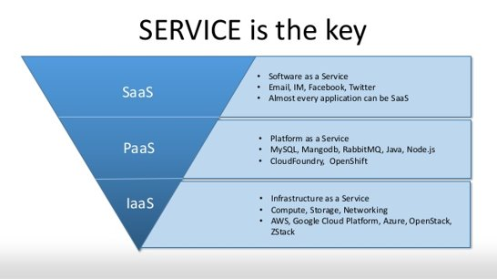
Cloud services models

1.8 Deployment models (security and privac issues)
- Private cloud
  - Infrastructure for one organization
  - Cost a lot
    - Self-run data centers – space, hardware, environmental controls
    - Updated regularly
  - Very secure
- Public cloud
  - Available over network open to public
  - Security concernts higher – extra protective measure against potential threats
  - Example: Google Cloud platform, Microsoft Azura, Amazon Web Services
Access through the internet
- Hybrid cloud
  - Private cloud: sersitive data
  - Public cloud: scalable, high-demand applications
  - Flexible by allowing where to run their applications based on cost, performance, and security needs

Difference elasticity and scalability
- Elasticity: Kan beide uitbreiden als verminderen in resources
- Scalibility: blijft groeien door resources toe te voegen, vaak met lange-termijnfocus

Amazon Web Services Introductions

AWS categories of services

Storage
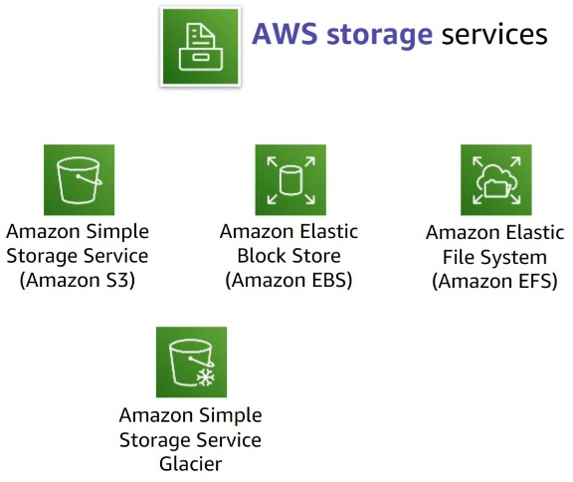
- Amazon S3
  - Storage for data, supporting applications like website, mobile apps, and data analytics
- Amazon EBS
  - Support intensive workloads like databases and enterprise applications
- Amazon EFS
  - Manage NFS file system
- Amazon S3 Glacier
  - Secure and low-cost storage for long-term backup

Compute
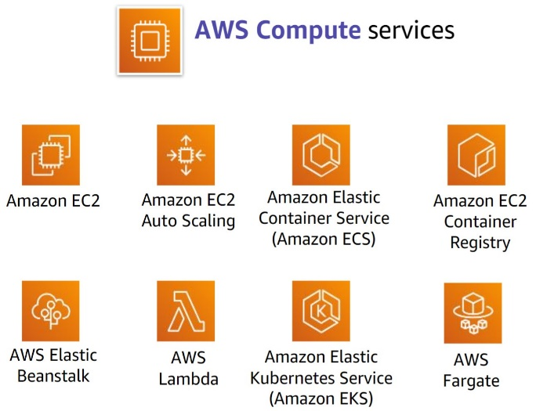
- Amazon Elastic compute cloud (Amazon EC2)
  - Provides resizable virtual machines in cloud
- Amazon EC2 auto scaling
  - Auto add or remove EC2 instances according to conditions
- Amazon elastic container service
- Amazon elastic container registry
- AWS elastic beanstalk
- AWS lambda

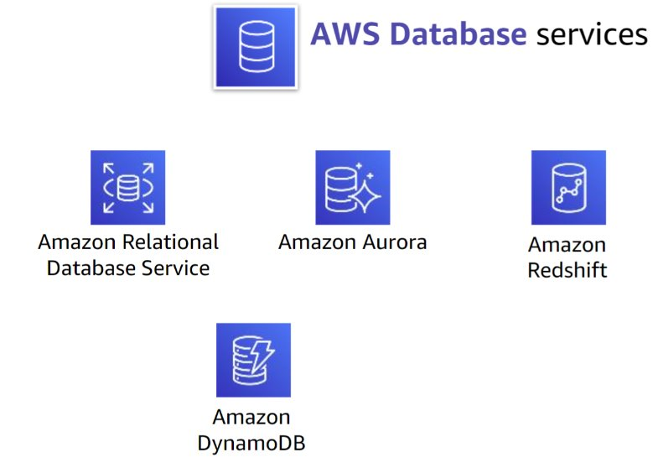
Database
- Amazon RDS
  - Automate tasks like hardware provioning and backups
- Amazon Aurora
  - Offering 5x performance of MySQL
  - 3x PostgreSQL
- Amazon Redshift
- Amazon DynamoDB
  - Key-value and document database
  - Built-in security, and caching

Networking and content delivery
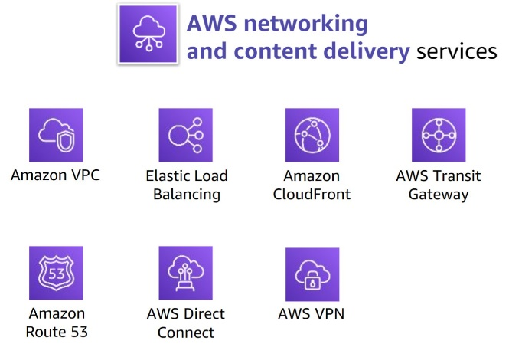
- Amazon VPC
- Elastic Load Balancing
- Amazon CloudFront
- AWS Transit Gateway
  - Connects VPCs + on-premises networks THROUGH central hub
- Amazon Route 53
- AWS Direct Connect

security, indendity and complaince
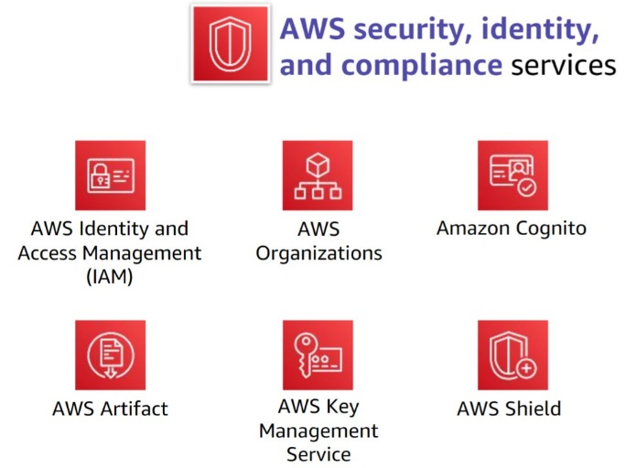
- AWS Identity and Access Management (IAM)
  - Create/manage AWS users/group
- AWS Organizations
- Amazon Cognite
- AWS Artifact
  - Provide on-demand accesss to Aws security
- AWS Key Management Service (AWS KMS)
  - Create/manage key
- AWS Shield
  - Safeguards app on AWS

Cost Management

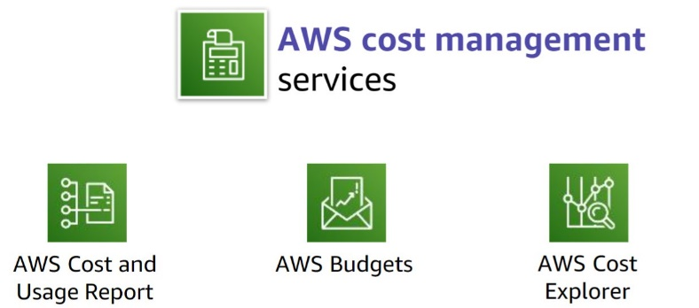

2.1.7 Management and Governance service category
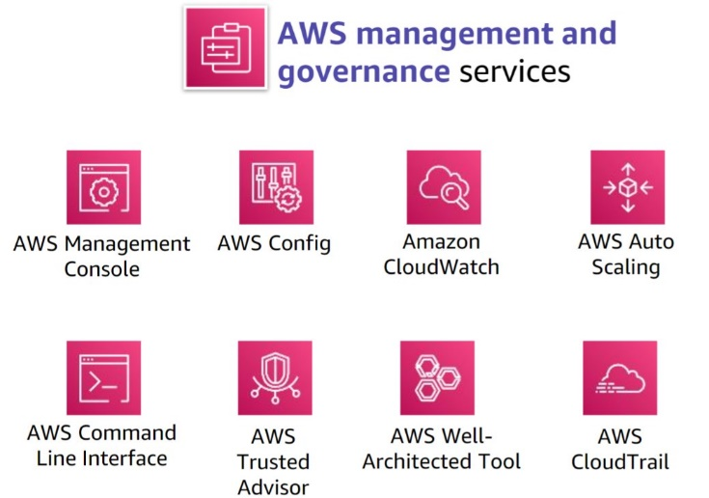

3.1 AWS Regions
- Is a geographical area
- Consists of 2+ Availability zone
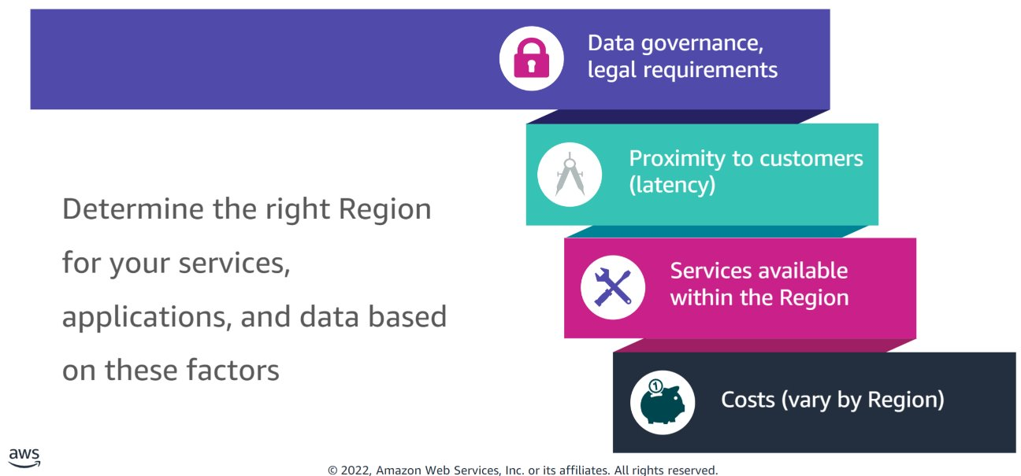

3.2 backbone network
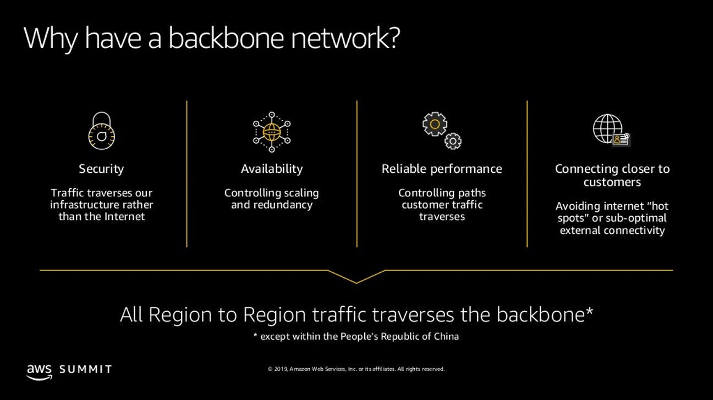

Compute -Amazon Elastic Compute (Amazon EC2)

Amazon Elastic Compute Cloud (Amazon EC2)

3.1.1 Amazon EC2 Overview
- Provides virtual machines – referred to as EC2 Instances – in the cloud
- Gives full control over the guest operating system on each instance
- Launch instances into Availability Zone anywhere in the world
- Control traffic to/from instances

3.1.2 VMs in other cloud platforms
Amazon Web Services (AWS) | Microsoft Azure | Google Cloud Platform (GCP)
Amazon Elastic Compute Cloud (EC2) | Azure Virtual Machines | Google Compute Engine (GCE)
EC2 instances | Azure VM instances | GCE instances
Guest operating system | Azure VM operating system | GCE VM operating system
Amazon Machine Images (AMIs) | Azure VM images | Google Machine Images (GMIs)
Launch EC2 instances | Create VM instances | Start GCE instances
Elastic IP | Azure Public IP address (Static) | GCE Static External IP
Region | Azure Region | GCP Region
Availability Zone | Availability Zones | Zones

3.1.3 Launching EC2 instance
- Select AMI
  - AMI = Amazon Machine Image
- Template used to create EC2 instance, which containts Linux or Windows OS
- Components:
  - Template for root volume which containts OS
  - Launch permissions: Control AWS accounts
  - Block device mapping: specify volumes to attach to the instance when it is launched

- Select instance type
  - Categories
- General purpose
- Compute optimized
- Memory optimized
- Storage optimized
- Accelerated computing
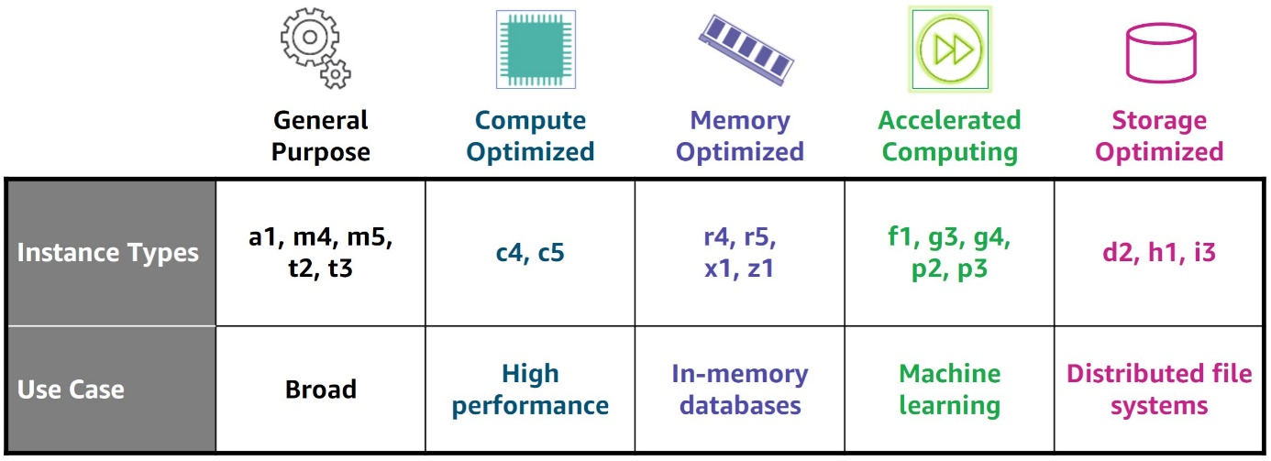
  - AWS graviton
ARM-based CPU designed by AWS subsidiary Annapurna Labs
Low enery use, static clock rates and multithreading

- Indentify or create the key pair
  - Key pairs
- Public key that AWS stores
- Private key that you store
  - Linux AMI
- Use private key to use SSH to securely connect to your instance
  - Windows AMI
- Use private key to obtain admin password you need to log in to your instance

- Specify Network settings
- Identify VPC and subnet
- Public IP address automatically assignet to make internet-accessible
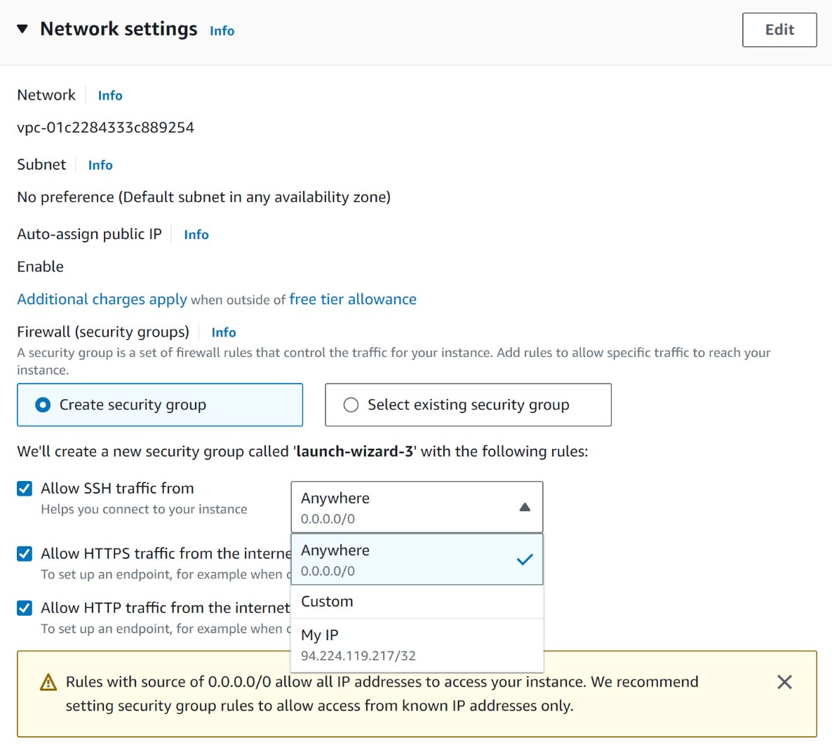
- Security group is a set of firewall rules
- Exist outside of instance’s guest OS

- Apply principle of least privilege. Only open what you need
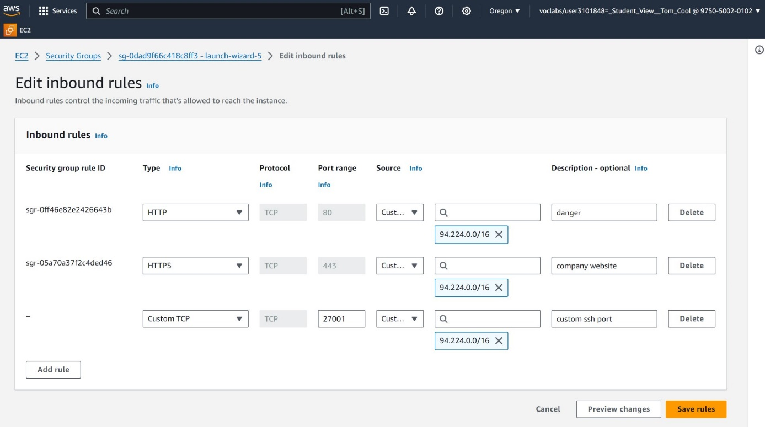

- Configure Storage
- Configure Root volume (where guest OS is installed)

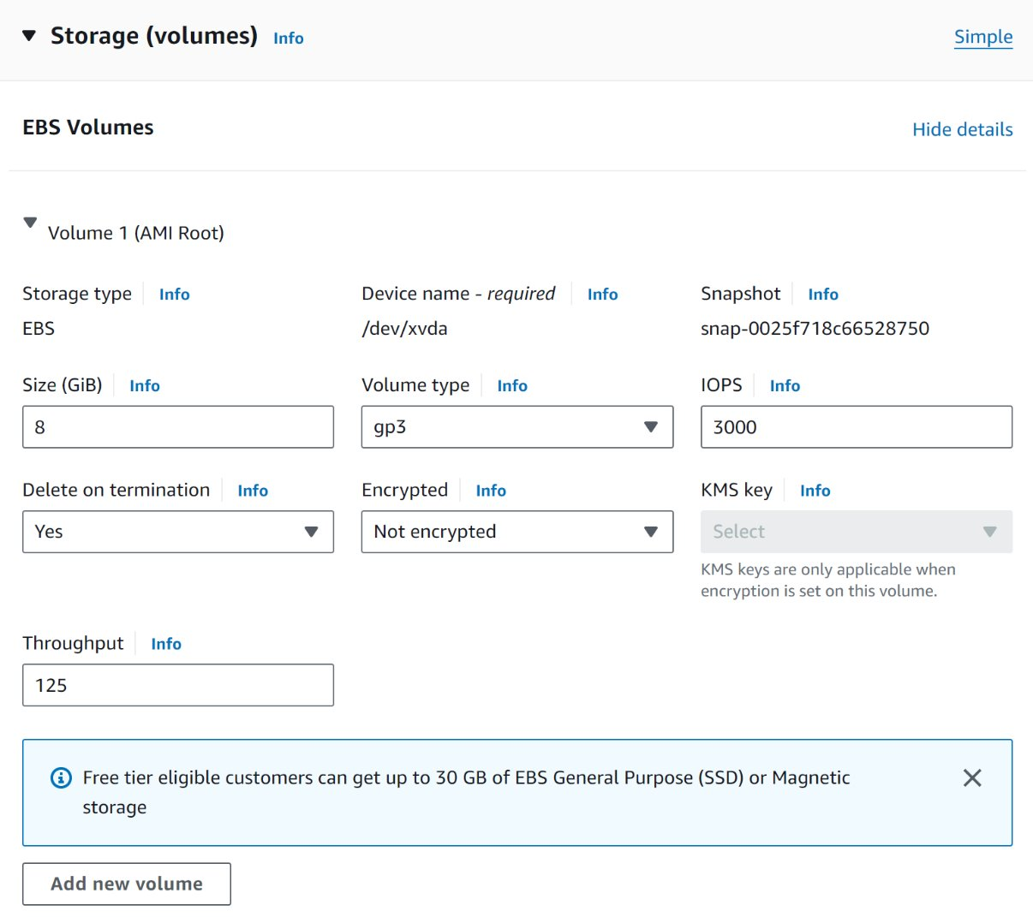

Amazon EC2 Auto Scaling

3.3 AWS Lambda

Storage

Storage Categories
- File storage
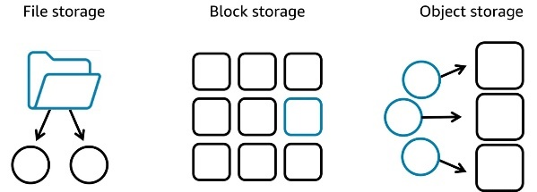
  - Hierarchy of files in directories and subdirectories managed by a file system
  - Example: Home directoryes, shared corporate documents, app workloads
that require a shared file system, …

- Block storage
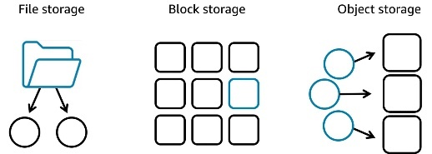
  - Splits data into equal sized blocks for frequent requiring and accessible via a
Unique address
  - Example: rapid read an write operations, such as databases and containers,
like virtual machines

- Object storage
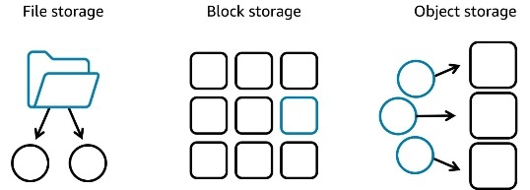
  - Manages data as objects. Each object incl. data, metadata and
uniqueidentifier
  - Object stored in Flat environment with no limits => scalable
  - Good for unsctructured data
  - Example: photos, video content, and backup archives

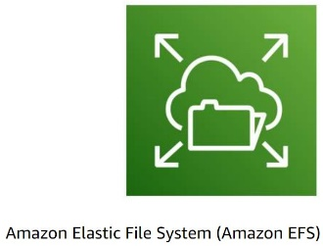
File storage - Amazon EFS
  - Elastic resizing: sclaes automatically with your files
  - Cost-effective: pay for what you use
  - Delivers consistent performance for each connected instance

Block storage - Amazon EC2 and EBS
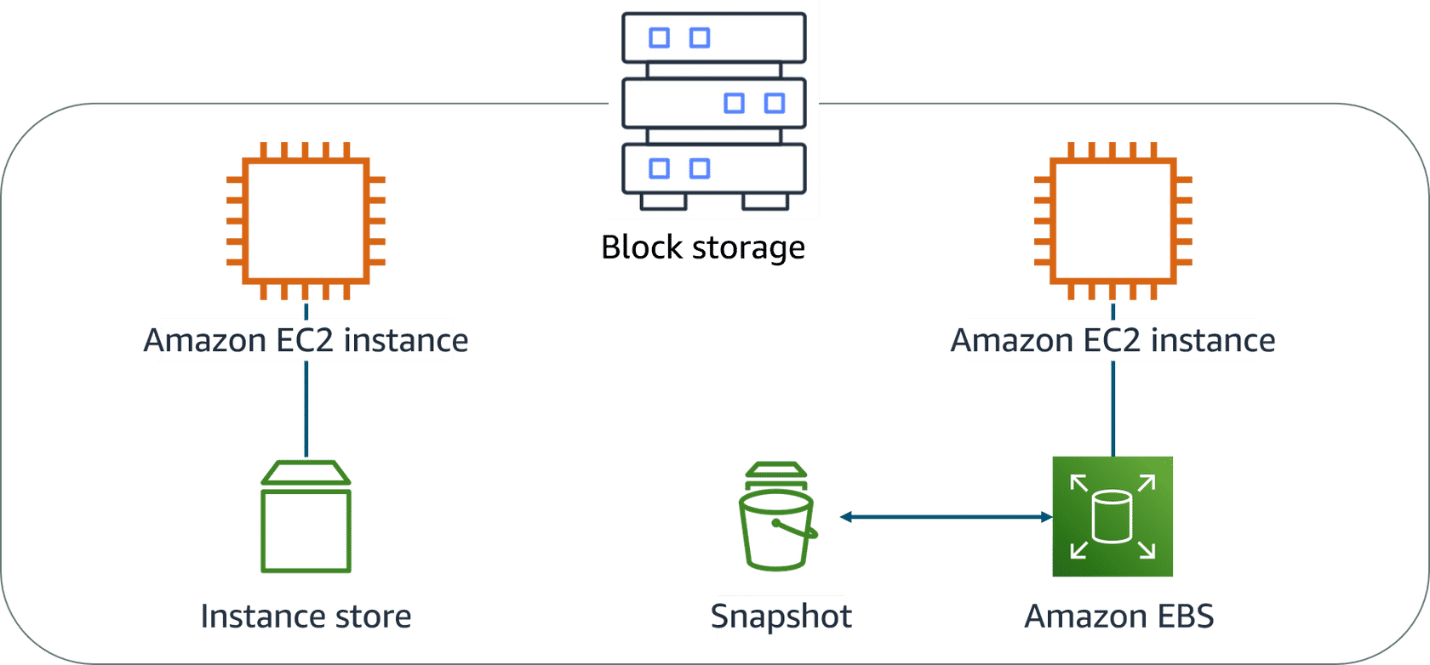
- Amazon EC2 Instance Store
  - Temporary block storage physically attached to the host computer
  - Delete EC2 instance = data loss
  - Designed for short-term use
  - Good for apps requiring fast data replication across EC2 instances
- Amazon EBS
  - Detachable external drives
  - Delete EC2 instance = no data loss (separate storage)
  - Designed for one-to-one connection with a single EC2 at a time

- Amazon EBS: Volume Types
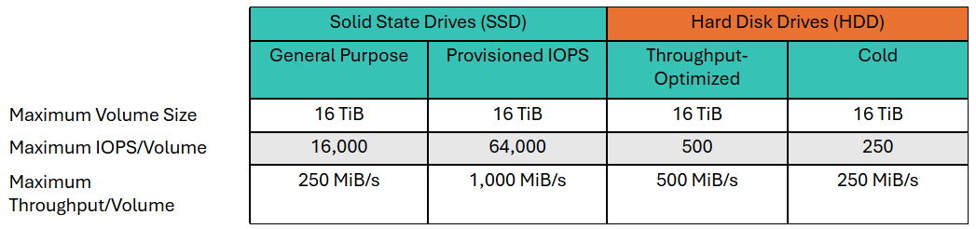
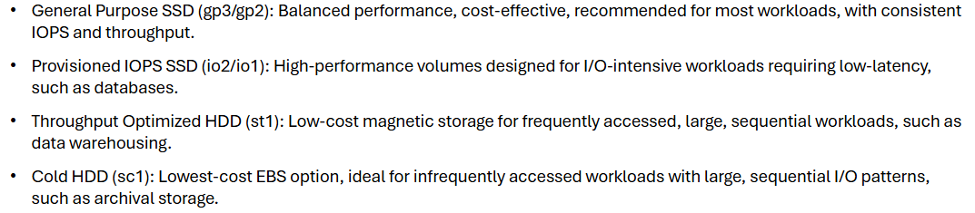
- Amazon EBS: Features
  - Snapshots for backup and scaling
    - Data transfer: Inboud is free, outbound data transfer is charged
    - Very complex to maintain large volumes. Requiers a lot of attention.
  - Encryption
    - Encrypted Amazon EBS volumes
    - No Extra costs
  - Elasticity
    - Eigenschappen
      - Dynamically adjuct capacity
      - Performance
      - type of EBS volumes without downtime

Object storage - Amazon S3 Standard
Buckets are globally unique (Buckets = objects(files+metadata) stored in buckets and have unique keys)
- Eigenschappen:
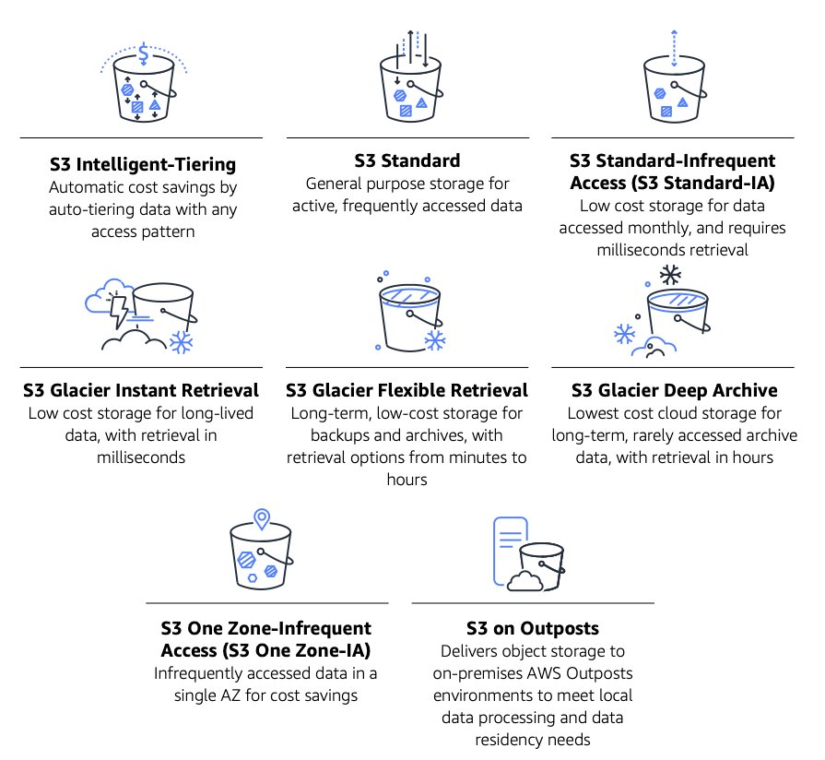
  - Scalable – allows users to store and retrieve any amount of data from anywhere on the web with high durability, availability, and security
    - Example: static website hosting (management lightweight web application)
  - Virtually unlimited storage
    - Example: Store/analyze large datasets like Amazon Redshift or Arthena, with scalable storage both structured and unstructured data
  - Cost-efficient
    - Example: hosting video and image content


Object storage – Amazon S3 Glacier
- Eigenschappen:
  - Data archiving service xtremely low cost
  - Upload cheap
  - Object size up to 40TB
- Lifecycle
  - A set of policy rules that automates the management of objects in an S3 bucket throughout their lifecycle
  - Helps control storage costs by defining actions or deleting objects after a specific period
  - Policies based on object age or tags, ensuring optimized storage without manual intervention
